**CURRICULUM-VITA**.

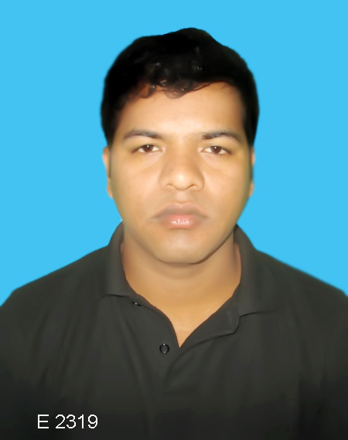

**MD. Anisur Rahman Sumon**

**Contact Number: - 01714-253795**

**Email: sumon.ct.2019@gmail.com**

* **Carrier objective:**

I want to build up my carrier by challenging all kind of feedback and my academic background will support me. And my general knowledge and concentration will have fall on my profession.

* **Experience:**

**Mahid Apprels Ltd ( Jaj Bhuiyan Group)**

Position: Store In-Charge (Yarn & Grey Store)

Duration: **To Still Now**

Co. Location: Nowpara, Madhobdi, Narshingdi.

* **Experience:**

**Cotton Club BD LTD ( Mondol Group)**

Position: Store In-Charge ( Grey Fabric Store)

Duration: 1 Years 2 Month.

Co. Location: Surabari Kashimpur Gazipur Dhaka

* **Experience:**

**GTA Sports Ltd. ( Niagara Textile LTD )**

Position: Store In-Charge (Dyeing Finishing Store)

Duration: 4 Year 6 Month.

Co. Location: GohailBari, Zirani, Savar Dhaka

* **Experience:**

**GTA Sports Ltd. ( Niagara Textile LTD )**

Position: Store In-Charge (Grey Store)

Duration: 2.5 Year 1 Month.

Co. Location: GohailBari, Zirani, Savar Dhaka

* **Experience:**

**GTA Sports Ltd. ( Niagara Textile LTD )**

Position: General Store

Duration: 1Year 3 Month.

Co. Location: Zirani, Savar Dhaka.

**Properties: Company**

* Maintained database of available inventory.
* Customer service abilities
* Arranged for national and international fabric shipments
* Prepared reports on seasonal fabric trends
* Communicated with vendors and held regular meetings and conference calls.
* Kept clients informed of project progress.
* Updated listing of available fabric choices.
* Prepared reports on seasonal fabric trends
  + **COMPUTER Skill:**

I have been completed in office Application Program {M.S Word, M.S Excel, Power point, English, Bangle type, & (**ERP Software all work**) etc.}. Graphics, Adobe Photoshop & Internet browsing etc.

Technology Summary

|  |  |  |  |  |
| --- | --- | --- | --- | --- |
| **Systems:** | **Linux** | | **Windows** | |
| **Databases:** | **Mongo DB** | | | **MYQSL** |
| **Languages:** | **HTML** | | **JavaScript,** | **Node JS** |
| **Framework** | **Bootstrap** | **React** | **Material Ul** | **CSS** |
| **Software:** | **MS Office** | **Purl** | **ERP solutions** | |

**Modern Communication skills / Experience**:

* Able to write Computer & Manual Challah
* Have ability speak in English
* Impressive knowledge of fabric manufacturing and dying processes
* Strong ability to utilize industry contacts to meet production demands
* Ability to work well under pressure while meeting strict deadlines
* Willing to work varied hours to meet client demands
* Extensive communications and organizational abilities
* **Academic info:**

**Degree.**

Collage name: Gov’t Bangla Collage of B.S.S

Board: National University Gazipur.

Passing year: incomplete 3nd year.

**Higher Secondary certificate (HSC)**

Collage Name: Bhurungamari Degree Collage.

Board: Dinajpur

Major: Business Studies

Passing Years: 2013

GPA: 2.70

**Secondary school certificate (SSC)**

School Name: Bhurungamari pilot high School.

Board: Dinajpur

Major: Science

Passing Years: 2010

**GPA: 3.31**

* + **PERSONAL PROFILE:**

Father’s Name : Md. Abdul Lotif.

Mother’s Name : Miss. Anowara Begum

Present Address : Vill- Gohail Bari,

P.O- Shimulia,

P.S- Ashulia,

Dist. - Dhaka.

Permanent Address : Vill- Bagvender,

P.O- Bhurungamari,

P.S - Bhurungamari,

Dist. - Kurigam.

Date of Birth : 22.06.1994.

Nationality : Bangladeshi (By birth)

Marital status : Married

Religion : Islam (Sunni)

**DECLARATION**

I thereby, inform positively that all of the information above is true and accurate to best of knowledge.

**________________________**

**ANISUR RAHMAN SUMON**